Profile of the

Multi-County Metropolitan

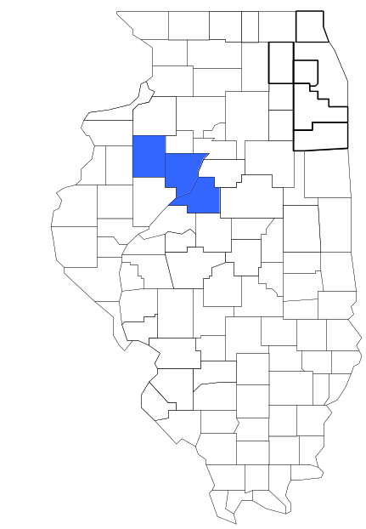Enforcement Group

Prepared by

The Research and Analysis Unit of the
Illinois Criminal Justice Information Authority

George H. Ryan, Governor
Peter B. Bensinger, Chairman
Candice M. Kane, Executive Director

March 2001



ILLINOIS
CRIMINAL JUSTICE
INFORMATION AUTHORITY

This project was supported by Grant # 99-DB-BX-0017, awarded to the Illinois Criminal Justice Information Authority by the Bureau of Justice Assistance, Office of Justice Programs, U.S. Department of Justice. The Assistant Attorney General, Office of Justice Programs, coordinates the activities of the following programs, offices and bureaus: Bureau of Justice Assistance, Bureau of Justice Statistics, National Institute of Justice, Office of Juvenile Justice and Delinquency Prevention, and the Office for Victims of Crime. Points of view or opinions contained within this document are those of the authors and do not necessarily represent the official position or policies of the U.S. Department of Justice.

Illinois Criminal Justice Information Authority
120 S. Riverside Plaza, Suite 1016
Chicago, Illinois 60606-3997
Telephone (312) 793-8550
Telefax (312) 793-8422
TDD: (312) 793-4170
World Wide Website http://www.icjia.state.il.us
ACKNOWLEDGMENTS

A number of organizations and individuals put a great deal of effort into the development of this document. The Authority’s Research and Analysis Unit is very grateful for the assistance provided by the following organizations:

Administrative Office of the Illinois Courts
Illinois Department of Human Services’ Office of Alcoholism and Substance Abuse
Illinois Department of Children and Family Services
Illinois Department of Corrections
Illinois State Police
Multi-County Metropolitan Enforcement Group
U.S. Bureau of the Census

In addition, the following individuals were instrumental in gathering, interpreting and presenting these data:

Sharyn Adams

Megan Alderden

Robert Bauer

Alissa Clark

John Condne

Karen Griffiths

Tracy Hahn

Jennifer Hiselman

David Katz

Joseph Kozenczak

Gary Kupsak

Erica Morrow

David Olson

Adrianna Perez

Gerard Ramker

Robert Taylor

CONTENTS

Section Page Number

EXECUTIVE SUMMARY

I. Introduction 1
II. Trends in Violent Index Offenses and Arrests 3
III. Trends in Drug Arrests 6
IV. Trends in Drug Seizures 15
V. Trends in Prosecutions for Drug Offenses 17
VI. Trends in Percent of Convicted Drug Offenders Sentenced to Prison 19
VII. Trends in Drug Treatment Admissions in Multi-County MEG Region by
Drug Type 24
VIII. Trends in Drug Exposed Births 27
IX. Summary of Drug Situation 28
X. Appendices 30
Map 1 1999 Percent of Illinois' County-level Population Covered by an
Authority-funded Multi-jurisdictional Enforcement Group or Task Force 31
Map 2 1999 Illinois Cannabis Seizure Rates, by County 32
Map 3 1999 Illinois Controlled Substances Seizure Rates, by County 33
Map 4 1999 Illinois Methamphetamine Seizure Rates, by County 34
XI. Bibliography 35

LIST OF FIGURES

Figure Page Number

Figure 1. Violent Index Offense Rates for Participating and Non-participating Agencies in
Region Covered by Multi-County MEG 3
Figure 2. 1999 Violent Index Offenses* Reported by Participating and Non-participating
Agencies in Region Covered by Multi-County MEG 4
Figure 3. Violent Index Arrest Rates for Participating and Non-participating Agencies in Region Covered by Multi-County MEG 5
Figure 4. 1999 Violent Index Arrests* Reported by Participating and Non-participating
Agencies in Region Covered by Multi-County MEG 5
Figure 5. Total Drug Arrest Rates for Multi-County MEG and Participating and
Non-participating Agencies in Region Covered by Multi-County MEG 7
Figure 6. 1999 Drug Arrests* Reported by Participating and Non-participating Agencies in
Region Covered by Multi-County MEG 8
Figure 7. Total 1999 Drug Arrests* Reported by Participating and Non-participating
Agencies in Region Covered by Multi-County MEG, by Drug Type 8
Figure 8. Drug Arrests by Multi-County MEG 9
Figure 9. Percent of Total Drug Arrests Accounted for by Multi-County MEG 10
Figure 10. Cannabis Arrests Rates in the Region Covered by Multi-County MEG as
Reported by Participating Agencies, Non-participating Agencies and
Multi-County MEG 11
Figure 11. Percent of Cannabis Arrests Accounted for by Multi-County MEG
12
Figure 12. Controlled Substances Arrest Rates in the Region Covered by Multi-County
MEG as Reported by Participating Agencies, Non-participating Agencies and
Multi-County MEG 12
Figure 13. Percent of Controlled Substances Arrests Accounted for by
Multi-County MEG 13
Figure 14. Multi-County MEG Drug Arrests for Possession versus Delivery, by
Drug Type 14
Figure 15. Cannabis Seized and Submitted to ISP by Knox, Peoria and Tazewell Counties
and Seized by Multi-County MEG 15
Figure 16. Powder and Crack Cocaine Seized and Submitted to ISP by Knox, Peoria
and Tazewell Counties and Seized by Multi-County MEG 16
Figure 17. Number of Felony Filings in Knox, Peoria and Tazewell Counties 17
Figure 18. Total Multi-County MEG Drug Arrests and Percentage of Arrests
Resulting in Prosecution 18
Figure 19. Sentences Imposed on Felons Convicted in Knox, Peoria and Tazewell Counties
19
Figure 20. Sentences Imposed on Convicted Multi-County MEG Drug Offenders 20
Figure 21. Number of Drug Offenders Committed to IDOC by Multi-County MEG and
Region Covered by Multi-County MEG 21
Figure 22. Drug Offenders as a Percent of Total IDOC Commitments from Knox, Peoria,
and Tazewell Counties 22
Figure 23. Drug Offenders Committed to IDOC from Knox, Peoria and Tazewell Counties,
by Offense Class 23
Figure 24. Substance Abuse Treatment Admissions from Knox, Peoria and
Tazewell Counties 24
Figure 25. Comparison of Drug Arrests by Multi-County and Participating and
Non-participating Agencies vs. Drug Abuse Treatment Admissions in Knox,
Peoria and Tazewell Counties, 1999 26
Figure 26. Cases of Drug-Exposed Infants in Knox, Peoria and Tazewell Counties 27
Figure 27. Availability of Drugs in Illinois, 1998 28
Figure 28. Price Per Gram in Illinois, 1998 29

EXECUTIVE SUMMARY

Since 1989, the Authority’s Research and Analysis Unit has received funds under the federal Anti-Drug Abuse Act of 1988 to document the extent and nature of drug and violent crime in Illinois and the criminal justice system’s response to these offenses. As a result of these efforts, the Authority has amassed a large amount of data measuring the extent and nature of drug and violent crime in Illinois and the impact these crimes have had on the criminal justice system. In addition, as part of its monitoring and evaluation efforts, the Authority also requires funded programs to submit monthly data reports describing their activities and accomplishments. This profile is intended to provide a general overview of the drug and violent crime problem in the jurisdictions covered by Illinois’ MEGs and task forces, and the response to these problems by the units.

Although the data presented in this report are by no means inclusive of all indicators, they do provide a general overview of drug and violent crime and the response and impact of the criminal justice system. The following represent general conclusions that can be made based on the data analyzed for this report.

- In 1999, six local Illinois police agencies participated in Multi-County MEG (a participating agency is defined as one that contributes either personnel or financial resources to Multi-County MEG). Officers assigned to Multi-County MEG (totaling nine in 1999, six from participating agencies) accounted for 1 percent of the total number of sworn police officers working for agencies participating in Multi-County MEG.

- The violent Index offense rate was collectively higher across jurisdictions participating in Multi-County MEG than among the combined jurisdictions that did not participate in Multi-County MEG, although this difference began to decrease in recent years (page 3).

- The drug arrest rate tended to be higher in those jurisdictions participating in Multi-County MEG than in those jurisdictions not participating. Also, the drug arrest rate for Multi-County MEG was significantly less than the drug arrest rate of those participating in Multi-County MEG. This may be due to the fact that Multi-County MEG had only one percent of all officers working in the jurisdictions participating in Multi-County MEG (page 6).

- When comparing the types of drug offenders arrested by those agencies participating in Multi-County MEG, those agencies not participating, and Multi-County MEG, it was found that Multi-County MEG tended to target and arrest more serious drug law violators, specifically violators of the Controlled Substances Act, which tend to be felony-level offenses (page 9).

- The majority of all drug arrests reported by Multi-County MEG, for either violations of the Cannabis Control Act or the Controlled Substances Act, involve drug sale or delivery (page 14).

- Between 1993 and 1999, the amount of cannabis and cocaine seized by Multi-County MEG increased (pages 15 and 16).

- Between 1989 and 1999, the majority of all drug arrests by Multi-County MEG resulted in prosecution. Of these Multi-County MEG drug offender prosecutions, 67 percent were for violations of Controlled Substances Act. In addition, between 1989 and 1999, over one-half of all drug offenders who were prosecuted as a result of Multi-County MEG activity were convicted (page 18).

- In 1999, among those Multi-County MEG drug offenders convicted and sentenced, jail sentences accounted for the largest proportion (41 percent), followed by prison sentences (38 percent) and probation sentences (21 percent) (page 20).

- Between 1989 and 1999, prison sentences resulting from Multi-County MEG cases accounted for only 20 percent of all drug-law violators sent to prison from the region where Multi-County MEG operates (page 21).

- Unlike the arrests made by the participating and non-participating agencies, the arrests made by Multi-County MEG tended to involve the substances considered to be most serious (i.e., felony versus misdemeanor) and the substances for which a large proportion of community residents were seeking and receiving substance abuse treatment in 1999 (page 25).

I. Introduction

The Multi-County Metropolitan Enforcement Group (Multi-County MEG) covers the Illinois counties of Knox, Peoria and Tazewell. Combined, these counties had a 1999 total population of 366,335 – one percent more than in 1990. In 1999, six local Illinois police agencies participated in Multi-County MEG. These include the Peoria County Sheriff's Office, the Tazewell County Sheriff's Office and the following municipal police departments: East Peoria, Pekin, Peoria and Galesburg. These agencies served nearly 74 percent of the population in the three-county region covered by Multi-County MEG in 1999 (see Map 1 on page 31). A participating agency is defined as one that contributes either personnel or financial resources to Multi-County MEG.

In addition to agencies that participate in Multi-County MEG, these Illinois counties are served by 27 additional police departments that do not participate in Multi-County MEG. According to the Illinois State Police, county sheriffs and local police departments, in the three-county region covered by Multi-County MEG, combined, employed 633 full-time police officers as of Oct. 31, 1999, 488 of which work in an agency participating in Multi-County MEG. In comparison, there were a total nine officers assigned to Multi-County MEG in 1999, six of which were assigned by participating agencies and three from the Illinois State Police (ISP). Thus, the officers assigned to Multi-County MEG during 1999 accounted for a relatively small proportion—1 percent—of the total number of sworn police officers working in the participating police departments.

Since 1989, the Authority’s Research and Analysis Unit has received funds under the federal Anti-Drug Abuse Act of 1988 to document the extent and nature of drug and violent crime in Illinois and the criminal justice system’s response to these offenses. As a result of these efforts, the Authority has amassed a large amount of data measuring the extent and nature of drug and violent crime in Illinois and the impact these crimes have had on the criminal justice system. In addition, as part of its monitoring and evaluation efforts, the Authority also requires funded programs to submit monthly data reports describing their activities and accomplishments. To put this information into the hands of Metropolitan Enforcement Group (MEG) and drug task force directors and policy board members, the Authority’s Research and Analysis Unit has developed profiles – of which this is one – for each MEG and task force. The profile is intended to provide a general overview of the drug and violent crime problem in the jurisdictions covered by Illinois’ MEGs and task forces, and the response to these problems by the units.

In addition to administering federal block-grant funds that come to Illinois for crime control initiatives, the Illinois Criminal Justice Information Authority is also responsible for providing policymakers, criminal justice professionals and others with information, tools and technology needed to make effective decisions that improve the quality of criminal justice in Illinois. The Authority provides an objective system-wide forum for identifying critical problems in criminal justice, developing coordinated and cost-effective strategies, and implementing and evaluating solutions to those problems. The specific powers and duties of the Authority are delineated in the Illinois Criminal Justice Information Act (Illinois Compiled Statutes, Ch. 20, Sec. 3930). Two of the Authority’s many responsibilities are serving as a clearinghouse of information and research on criminal justice and undertaking research studies to improve the administration of criminal justice.

While the data presented in this report are by no means inclusive of all indicators, they do provide a general overview of drug and violent crime and the response and impact of the criminal justice system. In addition, these data are readily available and consistently defined through existing statewide data collection mechanisms. Some data presented in this profile have been analyzed differently than in previous years; therefore, caution must be taken when comparing numbers presented with previous profiles.

While a considerable amount of the information presented in this profile has been provided to the Authority by Multi-County MEG, a number of state agencies have also provided data to the Authority that are included in this report. Specifically, the Illinois State Police, the Administrative Office of the Illinois Courts, the Illinois Department of Human Services’ Office of Alcoholism and Substance Abuse, the Illinois Department of Corrections and the Illinois Department of Children and Family Services all provided data used to develop this profile. The support and cooperation of these agencies and their staffs have helped make this report an informative and timely source of information on the activities of the criminal justice system in Illinois.

- Trends in Violent Index Offenses and Arrests

While most of Illinois’ Metropolitan Enforcement Groups and drug task forces are primarily involved in drug enforcement activities, it is clear that the relationship between drugs and violence is particularly evident in a number of Illinois communities. In addition, a number of MEGs and task forces have increased their involvement in the investigation of violent crime, particularly that associated with gang activity and violence related to drug distribution, sale and turf battles. One of the most commonly used indicators of the level of crime in a particular jurisdiction is the number of Index offenses reported to the police. In Illinois, as part of the Illinois Uniform Crime Reporting (I-UCR) program, every law enforcement agency in the state is required to report crime data monthly to the Illinois State Police (ISP). There are eight separate offenses that constitute the Crime Index, including murder, criminal sexual assault, robbery, aggravated assault (violent Index offenses), burglary, theft, motor vehicle theft and arson (property Index offenses). Although these eight offenses do not account for all crimes reported to the police, they are considered to be the most serious, frequent, pervasive and consistently defined by different law enforcement agencies.

In 1999, the number of violent Index offenses reported to the police in the three-county region covered by Multi-County MEG totaled 2,117, a 41 percent decrease from the 3,561 offenses reported in 1993. The majority (63 percent) of violent Index offenses reported to the police between 1993 and 1999 were aggravated assaults, while 22 percent were robberies.

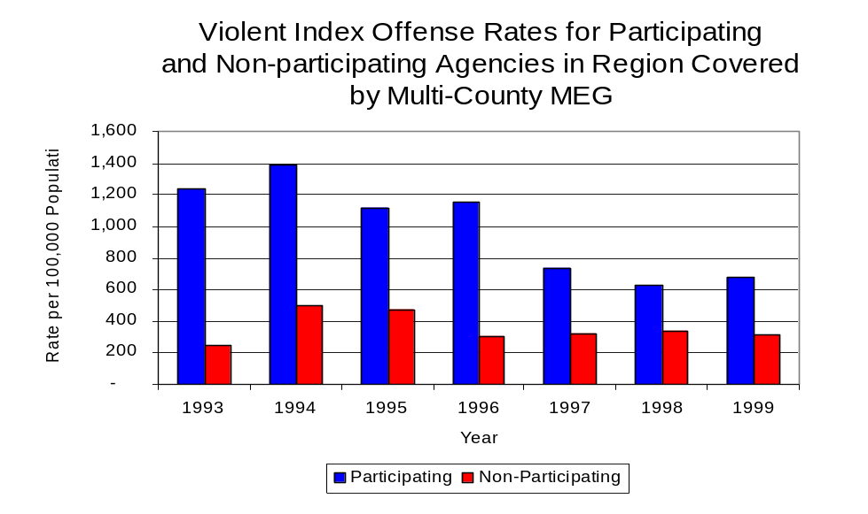
During the period analyzed, the violent Index offense rate for the region covered by Multi-County MEG decreased 41 percent, from 975 offenses per 100,000 population in 1993 to 578 offenses per 100,000 population in 1999. Similarly, the violent Index offense rate in the participating agencies decreased 45 percent, from 1,237 to 674 offenses per 100,000 population, while the rate in the non-participating agencies increased 24 percent, from 249 to 310 offenses per 100,000 population (Figure 1). Thus, the violent Index offense rate was collectively higher across jurisdictions participating in Multi-County MEG than among the combined jurisdictions that did not participate in Multi-County MEG, although this difference began to decrease since 1994.
Source: ICJIA calculations using
Illinois State Police and U.S. Census Bureau data
Figure 1

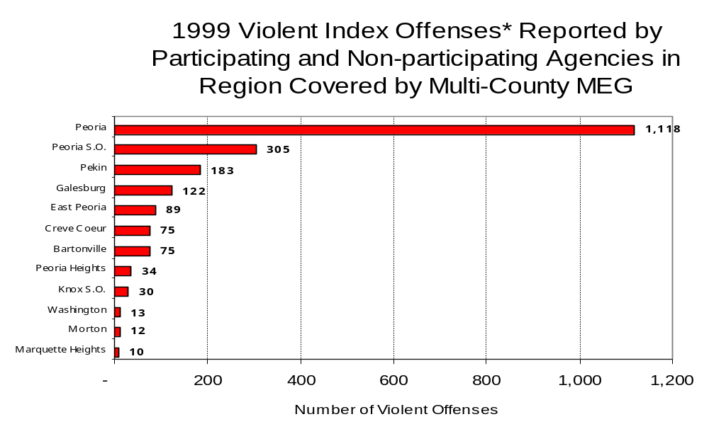
Source: Illinois State Police *Agencies reporting ten or more violent offenses
Figure 2
Across the 33 individual local law enforcement agencies covered by Multi-County MEG’s jurisdiction, three agencies, the Peoria Police Department, the Pekin Police Department and the Peoria County Sheriff's Office, accounted for 76 percent of all violent offenses reported to the police (Figure 2). Twenty-one agencies had fewer than ten violent offenses reported in 1999 and are excluded from Figure 2.

An indicator of the workload that law enforcement agencies place on other components of the justice system is the number of arrests made by police, including those for violent and property Index offenses and drug offenses. Unlike offenses, which are what police must respond to, arrests represent those offenders who may eventually be processed through other components of the justice system, including the courts, county jails, and state and local correctional programs.

Between 1993 and 1999, the number of arrests for violent Index offenses made by law enforcement agencies in the region covered by Multi-County MEG increased 11 percent, from 1,108 to 1,240. As with reported violent Index offenses, the majority (83 percent) of violent Index arrests were for aggravated assaults, followed by robberies (9 percent).

During the period analyzed, the violent Index arrest rate for the region covered by Multi-County MEG increased 12 percent, from 303 offenses per 100,000 population in 1993 to 338 arrests per 100,000 population in 1999. Similarly, the violent Index arrest rate in the participating agencies increased 11 percent, from 348 to 388 offenses per 100,000 population, while the rate in the non-participating agencies increased 13 percent, from 179 to 201 offenses per 100,000 population (Figure 3).

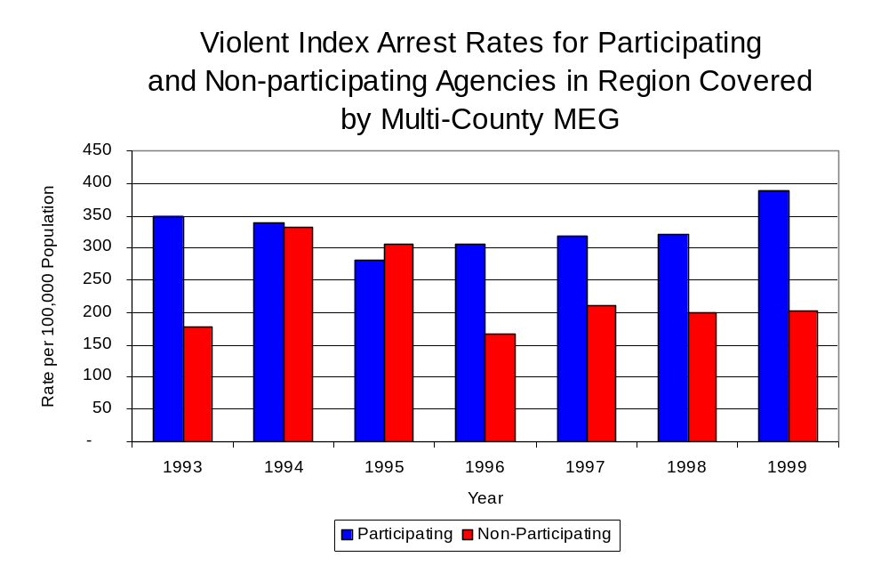
Similar to the number of violent Index offenses, the majority (74 percent) of arrests for violent
Figure 3
Source: ICJIA calculations using
Illinois State Police and U. S. Census Bureau data

Index offenses occurring in the three-county region covered by Multi-County MEG were made by three agencies. Twenty-four agencies had fewer than ten arrests for violent Index offenses reported in 1999 and are excluded from Figure 4. Of the 1338 violent Index arrests made in 1999, the Peoria Police Department accounted for the majority (49 percent), followed by the Pekin Police Department (15 percent) and the Peoria County Sheriff’s Office (10 percent).
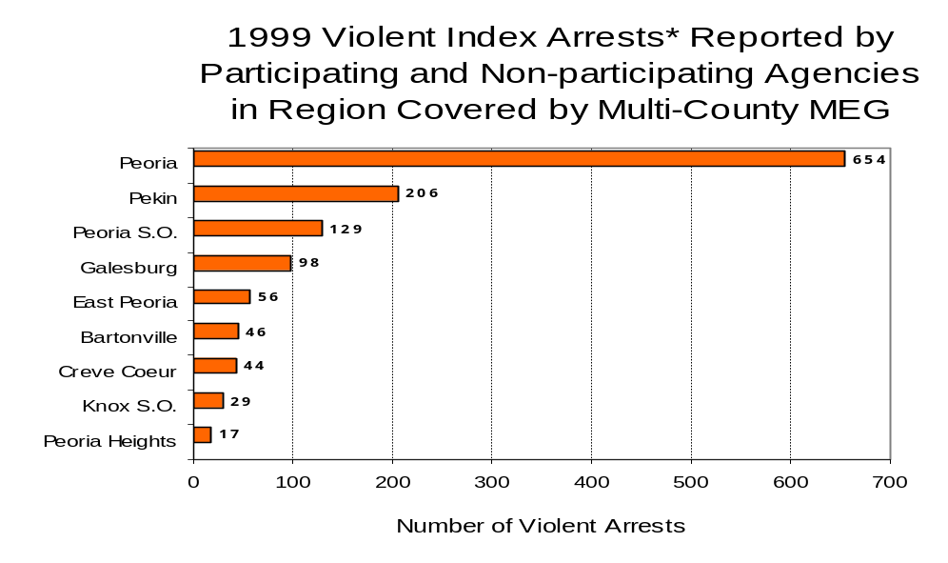
Figure 4
Source: Illinois State Police *Agencies reporting ten or more violent offenses
III. Trends in Drug Arrests

There are two sources of drug arrest data presented in this section. One source is the Illinois Uniform Crime Reporting (I-UCR) program that includes information submitted by local law enforcement agencies on the number of persons arrested for violations of Illinois’ Cannabis Control Act, Controlled Substances Act, Hypodermic Syringes and Needles Act, and Drug Paraphernalia Control Act. In addition, data on drug arrests made by Illinois’ MEGs and task forces are reported to the Illinois Criminal Justice Information Authority. In some jurisdictions, arrests made by the MEG or task force may be reported by both local law enforcement agencies through the I-UCR and to the Authority by the unit. In other jurisdictions, arrests made by the MEG or task force are only reported to the Authority by the unit. Therefore, in some instances drug arrests may be double counted – included in both local agency statistics reported to I-UCR and those of the MEG or task force. Currently there is no mechanism in place to ensure that drug arrest statistics are not being duplicated at both the local agency and MEG/ task force level. This should be kept in mind when interpreting the information presented in the following section.

The majority of drug offenses in Illinois are violations of either the Cannabis Control Act – which prohibits the possession, sale and cultivation of marijuana – or the Controlled Substances Act – which prohibits the possession, sale, distribution or manufacture of all other illegal drugs, such as cocaine and opiates. Illinois also has various other laws prohibiting other drug-related activity. These include the Hypodermic Syringes and Needles Act – which prohibits the possession or sale of hypodermic instruments – and the Drug Paraphernalia Control Act – which prohibits the possession, sale or delivery of drug paraphernalia. In general, violations of Illinois Controlled Substances Act are considered to be more serious, since they primarily involve cocaine, heroin, methamphetamine, and hallucinogens, and are almost all classified under Illinois law as felonies. The majority of cannabis and drug paraphernalia offenses encountered by police, on the other hand, tend to be misdemeanor-level offenses.

In 1999, local law enforcement agencies in the counties covered by Multi-County MEG reported 1,421 arrests for drug law violations, nearly triple the number in 1993 (507 arrests). Between 1994 and 1999, arrests for violations of Illinois’ Cannabis Control Act out-numbered arrests for violations of the Controlled Substances Act in Knox, Peoria and Tazewell counties, combined. During the same period, the number of arrests for violations of the Cannabis Control Act in these three counties combined more than tripled, from 253 to 957. Arrests for violations of the Controlled Substances Act in the three counties combined increased 83 percent, from 254 to 464. In addition, arrests for violations of the Drug Paraphernalia Control Act, enacted in 1993, increased dramatically from 16 in 1993 to 681 in 1999. Much of this increase can be attributed to a 1994 addition to the Drug Paraphernalia Control Act, which included the possession of drug paraphernalia as a violation.

Because arrests for violations of the Drug Paraphernalia Control Act are frequently made in conjunction with other drug offense arrests, these arrests may be double-counted, thus skewing the actual number of drug arrests. Therefore, only arrests for violations of the Cannabis Control Act and Controlled Substances Act will be used for drug arrest comparisons between Multi-County MEG and the participating and non-participating agencies.

During the period analyzed, the drug arrest rate for the Cannabis Control and Controlled Substances Acts combined, in the region covered by Multi-County MEG, more than doubled, from 139 arrests per 100,000 population in 1993 to 388 arrests per 100,000 population in 1999. Similarly, the drug arrest rate in the participating and non-participating agencies also more than doubled, from 150 to 428arrests per 100,000 population and 108 to 277 arrests per 100,000 population, respectively. The arrest rate for Multi-County MEG, on the other hand, increased slightly, from 34 to 36 arrests per 100,000 population (Figure 5). Thus, the drug arrest rate tended to be higher in those jurisdictions participating in Multi-County MEG than in those jurisdictions not participating. Also, the drug arrest rate for Multi-County MEG was

significantly less than the drug arrest rate of those participating in Multi-County MEG. This may be due to the fact that Multi-County MEG had only 1 percent of all officers working in the jurisdictions participating in Multi-County MEG.
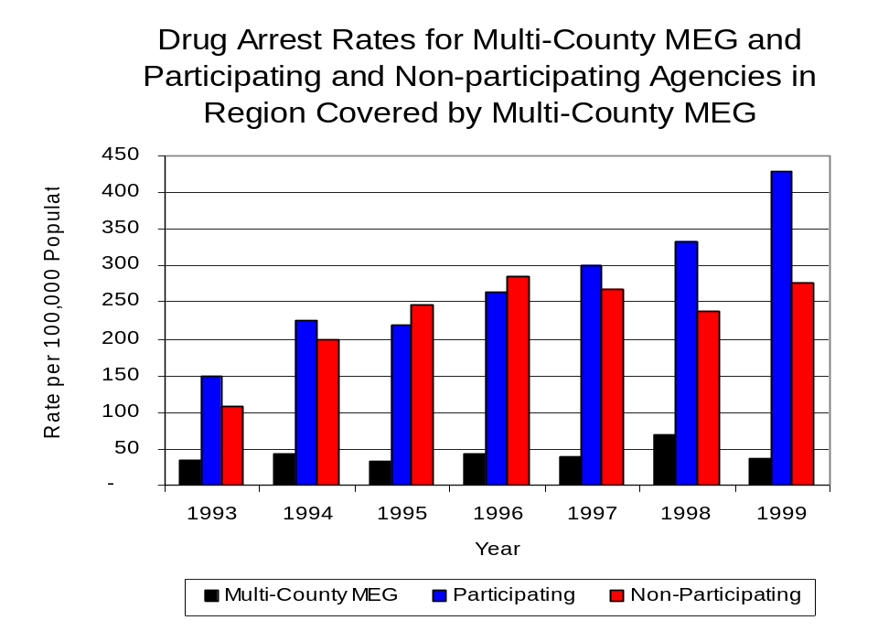
Source: ICJIA calculations using Illinois
State Police, Multi-County MEG and U.S. Census Bureau data
Figure 5

Across the individual local law enforcement agencies in the region covered by Multi-County MEG, the total number of drug arrests, including all types of drug offenses, ranged from zero to 752. Of the 2,380 drug arrests made during 1999 in the three-county region, four agencies accounted for 63 percent of these drug arrests. Sixteen agencies had fewer than ten drug arrests reported in 1999 and are excluded from Figure 6. The City of Peoria accounted for almost one-third (32 percent) of arrests in the region, while the Pekin Police Department accounted for 12 percent, the Galesburg Police Department accounted for 11 percent of the regional arrests and the Tazewell County Sheriff’s Office accounted for 9 percent all drug arrests in Knox, Peoria and Tazewell counties (Figure 6). All of the six agencies with the highest number of drug arrests reported participated in Multi-County MEG.

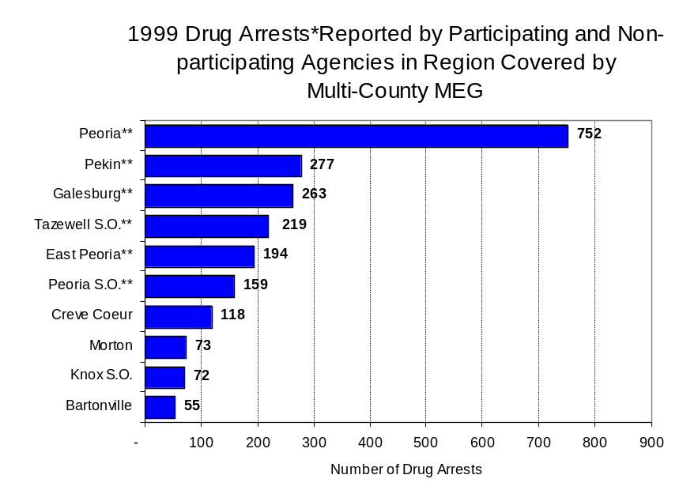
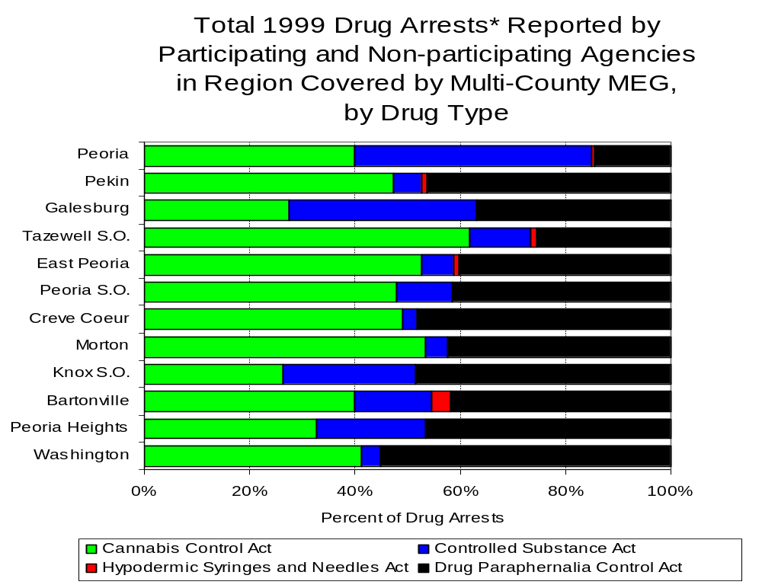
In addition to the dramatic difference in the number of drug arrests made, there are also differences in the types of drug law violation arrests across the agencies in the region. In 1999, violations of the Cannabis Control Act accounted for the largest proportion of arrests across most individual agencies in the region covered by Multi-County MEG (Figure 7).
Figure 6
Source: Illinois State Police *Agencies reporting 50 more drug arrests
**Agencies participating in Multi-County MEG
Figure 7
Source: Illinois State Police*Agencies reporting 25 or more drug arrests
Between 1993 and 1999, the number of combined cannabis and controlled substances arrests made by Multi-County MEG increased 8 percent, from 131 to 141 (Figure 8). Unlike drug arrests made by most local police departments in the region, violations of the Controlled Substances Act accounted for the majority of drug arrests made by Multi-County MEG throughout most of the period analyzed. During the period analyzed, the number of Multi-County MEG arrests for violations of the Cannabis Control Act decreased 23 percent, from 53 to 41, while arrests for violations of the Controlled Substances Act increased 28, from 78 to 100 (Figure 8).

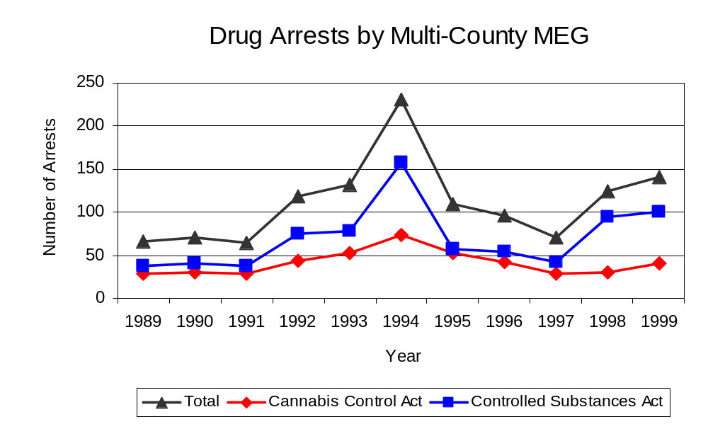
Between 1993 and 1999, the proportion of drug arrests accounted for by violations of the Controlled Substances Act increased for non-participating agencies as well as Multi-County MEG, but decreased for participating agencies. In 1999, 71 percent of the drug arrests made by Multi-County MEG were for violations of the Controlled Substances Act, compared to 60 percent in 1993. Thus, arrests by Multi-County MEG were more likely than arrests by either participating or non-participating agencies to involve violations of the Illinois’ Controlled Substances Act, as opposed to the Cannabis Control Act. One interpretation of this pattern is that Multi-County MEG was more focused in who they are targeting and arresting than local departments, and are also getting a more serious drug law violator, since violations of the Controlled Substance Act are more likely to involve felony-level offenses.
Source: Multi-County MEG
Figure 8

The data presented below represent the percent of total drug arrests made by participating agencies that were accounted for by Multi-County MEG. An upper and lower bound is shown in Figure 9, which accounts for whether or not the units numbers are counted as part of the UCR submissions made by participating departments (which is unknown at this point). The upper bound indicates the percentage of arrests if all of the Multi-County MEG arrests are included in the local UCR submissions. The lower bound indicates the percentage if none of the Multi-County MEG arrests are included in the local UCR submissions. It is estimated that the proportion of all drug arrests made in the jurisdictions of participating agencies, and accounted for by Multi-County MEG, was between 20 to 25 percent in 1993, but decreased to between nine to 10 percent in 1999. Despite the fact that the officers assigned to Multi-County MEG accounted for only one percent of the total number of officers in participating agencies, they accounted for almost ten percent of the drug arrests made in the jurisdiction of the participating agencies in most of the years analyzed.

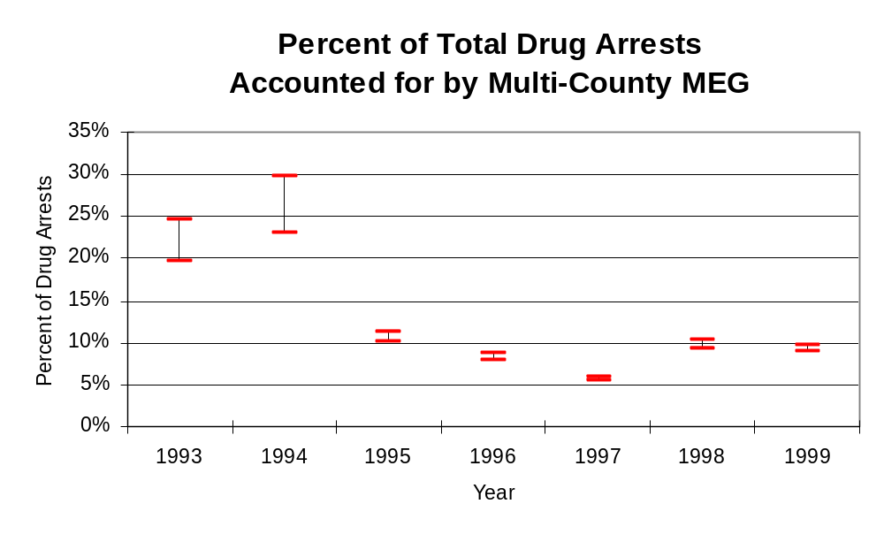
Figure 9
Source: ICJIA calculations using
Illinois State Police and Multi-County MEG data
The number of arrests for violations of Illinois’ Cannabis Control Act in Knox, Peoria and Tazewell counties combined totaled 1,029 in 1999, more than triple the 322 arrests made for cannabis violations in 1993. Agencies participating in Multi-County MEG accounted for the largest portion (79 percent) of the total number of arrests for cannabis violations. Multi-County MEG reported a total of 41 arrests for cannabis violations in 1999, 29 percent of the unit's drug arrests.

During the period analyzed, the cannabis arrest rate for the region covered by Multi-County MEG more than tripled, from 88 arrests per 100,000 population in 1993 to 281 arrests per 100,000 population in 1999. The cannabis arrest rate in the participating agencies more than tripled, from 88 to 303 arrests per 100,000 population, while the arrest rate in the non-participating agencies almost tripled from 88 to 220 arrests per 100,000 population. The cannabis arrest rate for Multi-County MEG, on the other hand, decreased 23 percent, from 20 to 15 arrests per 100,000 population (Figure 10). Thus, the arrest rate for violations of the Cannabis Control Act was higher in the area served by non-participating agencies until 1997, when the arrest rate for violations of the Cannabis Control Act was higher in the jurisdictions of those agencies participating in Multi-County MEG.

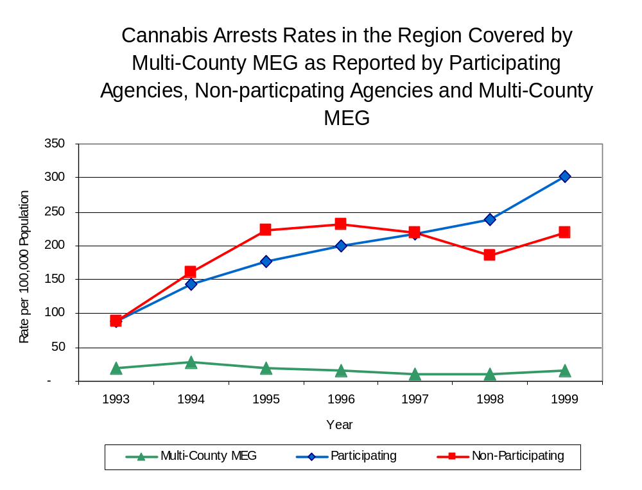
Source: ICJIA calculations using
Illinois State Police and Multi-County MEG data
Figure 10

The data presented below represent the percent of total arrests for the violation of the Cannabis Control Act made by participating agencies that was accounted for by Multi-County MEG. An upper and lower bound is shown in Figure 11, which accounts for whether or not the units numbers are counted as part of the UCR submissions made by participating departments (which is unknown at this point). The upper bound indicates the percentage of arrests if all of the Multi-County MEG arrests are included in the local UCR submissions. The lower bound indicates the percentage if none of the Multi-County MEG arrests are included in the local UCR submissions.

It is estimated that the proportion of all arrests for the violation of the Cannabis Control Act made in the jurisdictions of participating agencies, and accounted for by Multi-County MEG, was between 18 to 22 percent in 1993, but decreased to five percent in 1999. The data presented in Figure 11 suggest that although arrests for the violation of the Cannabis Control Act made by Multi-County MEG in 1993 represented a significant proportion of such arrests made in the jurisdictions of participating agencies, considering the number of officers working for Multi-County MEG, this proportion dropped in subsequent years.

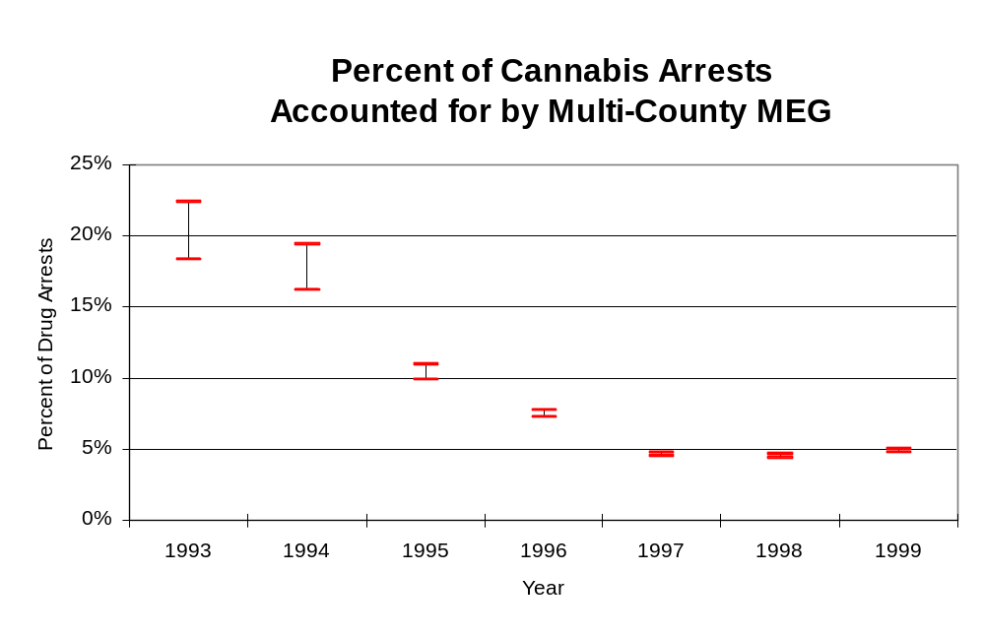
In Knox, Peoria and Tazewell counties the number of arrests for violations of Illinois’ Controlled Substances Act increased 77 percent between 1993 and 1999, from 316 to 558. In 1999, Multi-County MEG reported 100 arrests for controlled substance violations.
Figure 11
Source: ICJIA calculations using Illinois
State Police and Multi-County MEG data

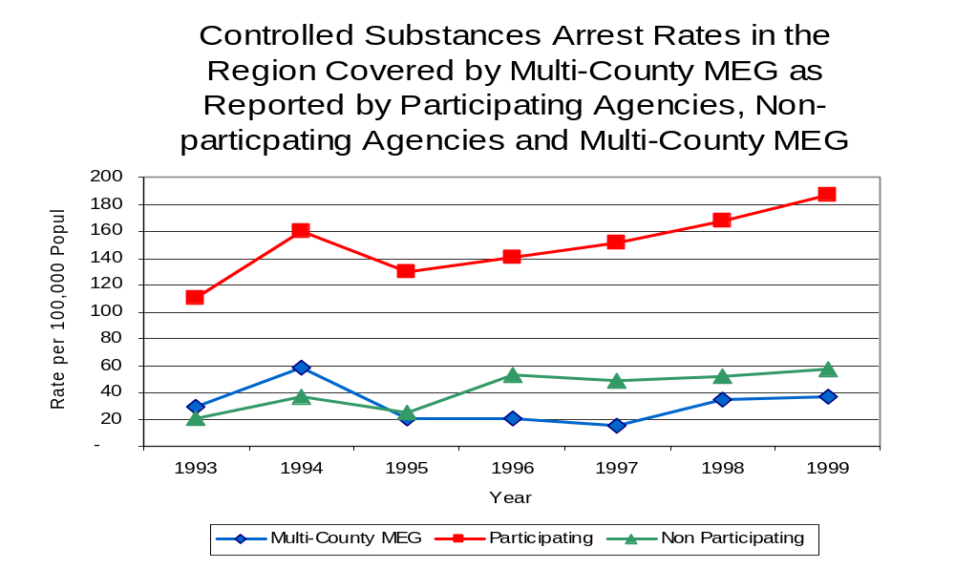
Between 1993 and 1999, the arrest rate for controlled substances act violations for the region covered by Multi-county MEG increased 76 percent, from 87 to 152 arrests per 100,000 population (Figure 12). The controlled substances arrest rate in the participating agencies increased 69 percent, from 110 to 187 arrests per 100,000 population, while the arrest rate in the non-participating agencies more than doubled, from 21 to 57 arrests per 100,000 population. The controlled substances arrest rate for Multi-County MEG increased 28 percent, from 29 to 37 arrests per 100,000 population (Figure 12). Thus, the arrest rate for violations of the Controlled Substances Act was higher for participating agencies than non-participating agencies.
Figure 12
Source: ICJIA calculations using Illinois State Police and Multi-County MEG data
The data presented below represent the percent of total arrests for the violation of the Controlled Substances Act made by participating agencies that was accounted for by Multi-County MEG. An upper and lower bound is shown in Figure 13, which accounts for whether or not the units numbers are counted as part of the UCR submissions made by participating departments (which is unknown at this point). The upper bound indicates the percentage of arrests if all of the Multi-County MEG arrests are included in the local UCR submissions. The lower bound indicates the percentage if none of the Multi-County MEG arrests are included in the local UCR submissions.

It is estimated that the proportion of all arrests for the violation of the Controlled Substances Act made in the jurisdictions of participating agencies, and accounted for by Multi-County MEG, was between 21 to 26 percent in 1993, but decreased slightly to between 17 to 20 percent in 1999. When examining the three figures together (Figure 9, 11 and 13), the data suggest that Multi-County MEG focused on arresting individuals violating the Controlled Substances Act, most of which are felony offenses.
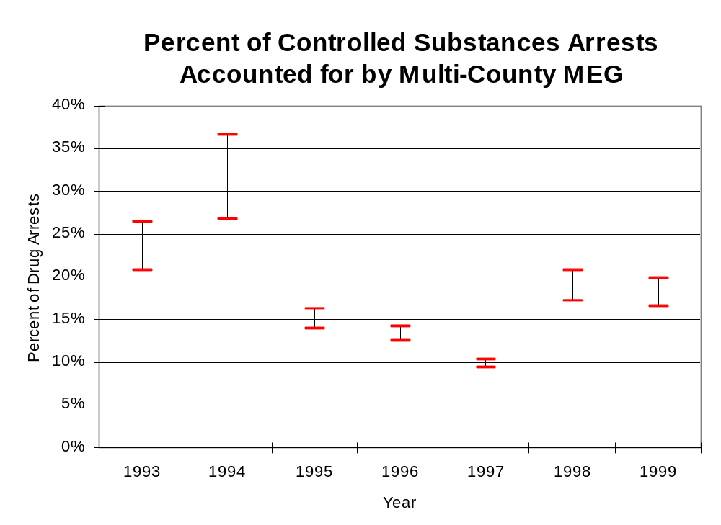
Figure 13
Source: ICJIA calculations using
Illinois State Police and Multi-County MEG data

The majority of all drug arrests reported by Multi-County MEG are for delivery. Between 1993 and 1999, the number of drug delivery arrests made by Multi-County MEG increased, from 102 to 112. Arrests for drug delivery accounted for over three-quarters (82 percent) of all drug arrests made by Multi-County MEG between 1993 and 1999. When cannabis and controlled substance arrests were examined separately, during the period analyzed, arrests for delivery of controlled substances accounted for 85 percent of the total number of arrests made for violations of the Controlled Substance Act, whereas, arrests for the delivery of cannabis accounted for 75 percent of all arrests for violations of the Cannabis Act. Thus, arrests for the delivery of cannabis or other controlled substances accounted for the majority of arrests made by Multi-County MEG.

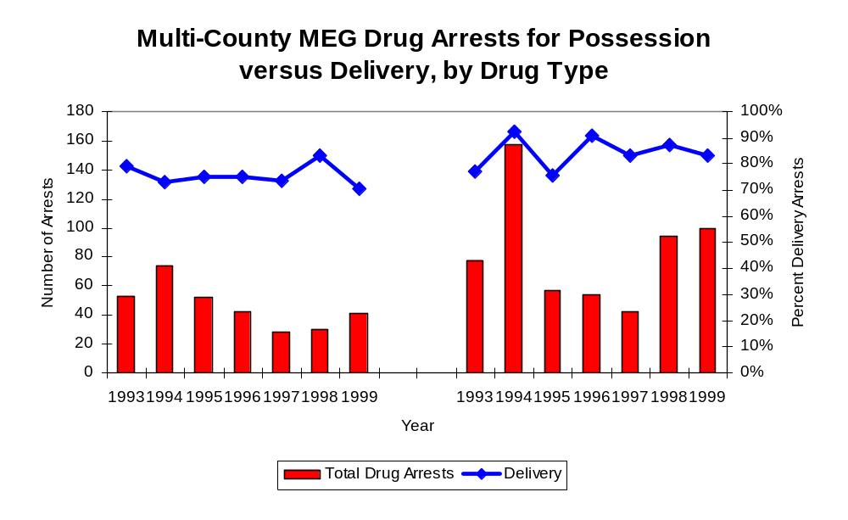
Figure 14
Source: ICJIA calculations using Multi-County MEG data
Cannabis Control Act

Controlled Substances Act

IV. Trends in Drug Seizures

Drugs seized by law enforcement agencies are another indicator of the extent and nature of illegal drug trade in a jurisdiction. When illegal drugs are seized by law enforcement agencies, all or a portion of the total amount seized is submitted to a crime lab for analysis. Most agencies submit drugs to one of the Illinois State Police crime labs. These labs record the quantity of drugs submitted from each county. This section discusses trends in the quantities of illegal drugs seized and submitted to the Illinois State Police from local law enforcement agencies in Knox, Peoria and Tazewell counties as well as the quantities of drugs seized by Multi-County MEG. It is important to note, however, that while Multi-County MEG data report the total quantities of drugs actually seized, local agency data only represent the quantities of seized drugs that are submitted to the Illinois State Police for analysis. County-level cannabis, cocaine and methamphetamine seizure rates for Illinois' 102 counties are provided in maps located in the Appendix of this report.

As in most Illinois jurisdictions, cannabis accounts for the majority of illegal drugs seized in the three-county region covered by Multi-County MEG. The quantity of cannabis seized and submitted by law enforcement agencies in Knox, Peoria and Tazewell counties increased 68 percent, from 25,439 grams in 1993 to 42,797 grams in 1999. However, the quantity of cannabis seized by Multi-County MEG increased six-fold between 1993 and 1999, from 31,291 grams to 209,939 grams (Figure 15). In 1999, Multi-County MEG's cannabis seizure rate of 77,919 grams per 100,000 population was double the statewide cannabis seizure rate of 31,533 grams per 100,000 population and nearly seven times the seizure rate of 11,682 grams per 100,000 population in the three-county region covered by Multi-County MEG (Map 2).
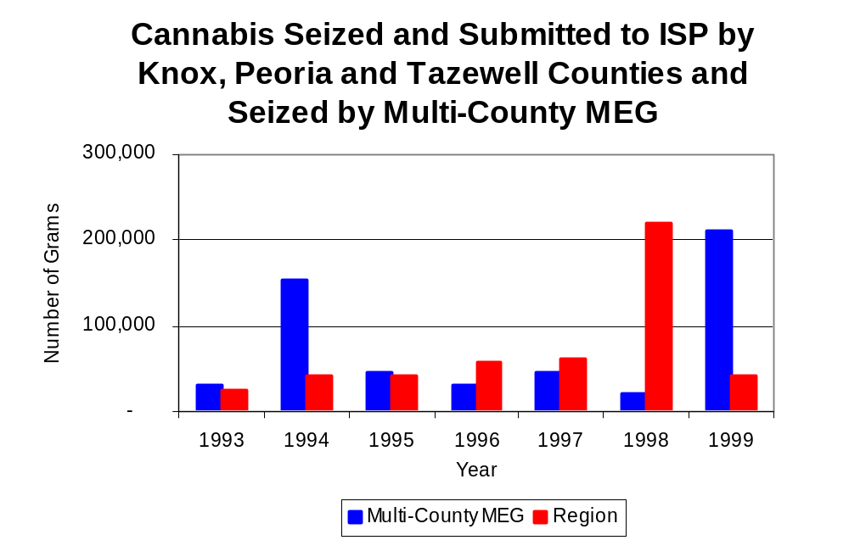
Figure 15
Source: Illinois State Police and Multi-County MEG

Between 1993 and 1999, a combination of crack and powder cocaine has accounted for a small proportion of drugs seized in the three-county region covered by Multi-County MEG. The quantity of cocaine seized and submitted by law enforcement agencies in Knox, Peoria and Tazewell counties decreased 47 percent, from 6,052 grams in 1993 to 3,235 grams in 1999. Between 1993 and 1999, the quantity of cocaine seized by Multi-County MEG increased 57 percent, from 834 grams to 1,312 grams.

As a result, the proportion of all cocaine seized accounted for by powder cocaine decreased from 85 percent in 1993 to 61percent in 1999 in the region covered by Multi-County MEG. In contrast, for Multi-County MEG, although powder cocaine accounted for the largest proportion of total cocaine seizures in all seven years examined, the proportion decreased from 100 percent in 1993 to 71 percent in 1999 (Figure 16). In 1999, Multi-County MEG's cocaine seizure rate of 487 grams per 100,000 population was almost one-half the cocaine seizure rate of 883 grams per 100,000 population in the three-county region covered by Multi-County MEG, but 97 percent less than the statewide cocaine seizure rate of 15,735 grams per 100,000 population (Map 3).
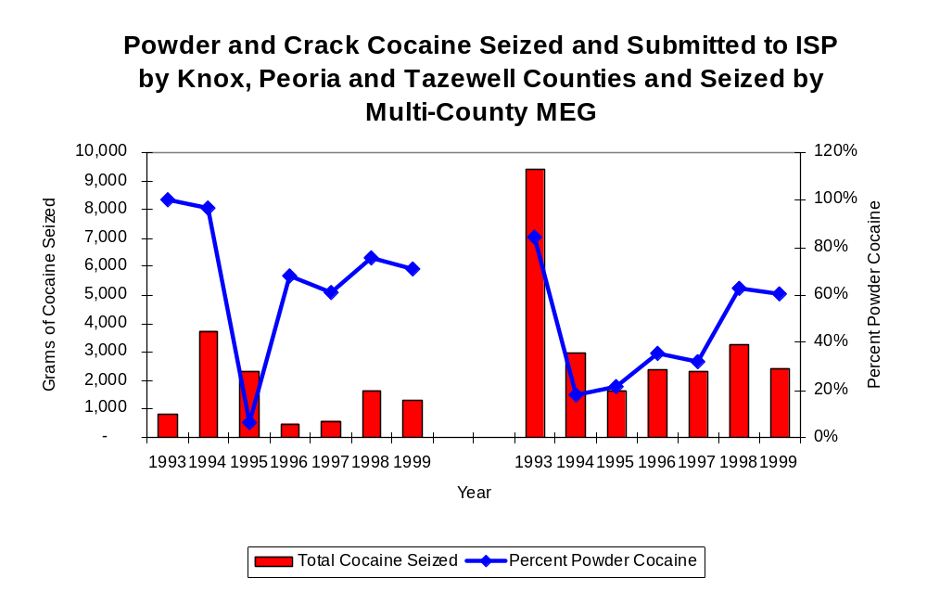
Figure 16
Source: Illinois State Police and Multi-County MEG
Multi-County MEG
Region

The total quantity of illegal drugs seized and submitted by law enforcement agencies in Knox, Peoria and Tazewell counties increased between 1993 and 1999, from 31,601 grams to 46,876 grams, with a high of 223,032 grams seized in 1998. On the other hand, the total quantity of illegal drugs seized by Multi-County MEG has increased from 32,285 grams in 1993 to 213,340 grams in 1999.

During the period, methamphetamine seizures accounted for a relatively small proportion of total drugs seized by Multi-County MEG and the region covered by Multi-County MEG. Although Multi-County MEG reported no methamphetamine seizures between 1994 and 1997, the quantity of methamphetamine seized by Multi-County MEG jumped from 61 grams in 1998 to 1,801 grams in 1999. There were less than 68 grams of methamphetamine seized by law enforcement agencies in the region covered by Multi-County MEG between 1994 and 1999, increasing from less than four grams to nearly nine grams. In 1999, Multi-County MEG had a seizure rate of 668 grams per 100,000 population, significantly higher than statewide and regional seizure rates of 98 grams per 100,000 population and two grams per 100,000 population, respectively (Map 4).

Trends in Prosecutions for Drug Offenses and All Felonies

Although Illinois has one of the best court reporting systems in the country, the Administrative Office of the Illinois Court only collects information regarding the aggregate number of court filings. Currently, there are no statewide data available on court filings by offense type. The Administrative Office of the Illinois Courts reports data on felony criminal court cases. After screening a case and deciding it warrants further action, the state’s attorney must file formal charges in court. Felony cases can be punished by a probation term up to four years and incarceration for more than one year.

Between 1989 and 1999, the number of felony filings in the three-county region covered by Multi-County MEG increased nearly every year. During the period analyzed, the number of felony filings increased 89 percent, from a period low of 1,377 filings to a period high of 2,598 filings (Figure 17).

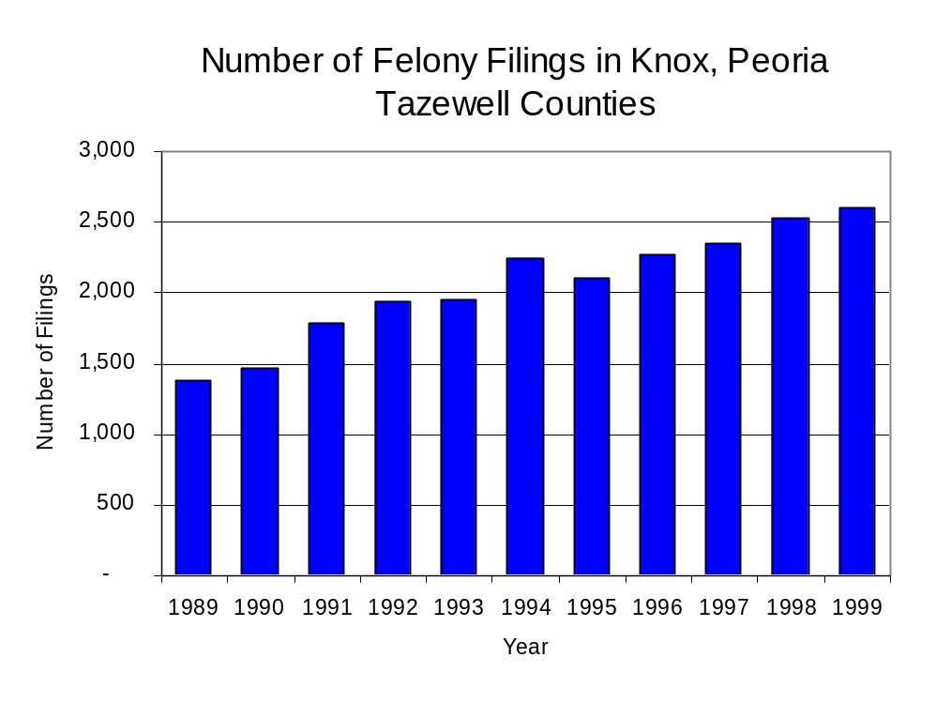
Figure 17
Source: Administrative Office of the Illinois Courts

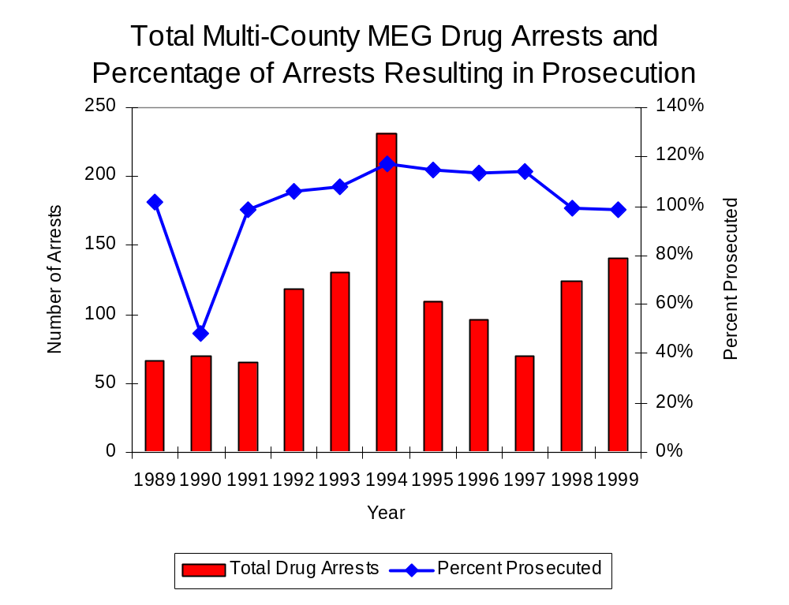
Between 1989 and 1999, there was a total of 1,278 drug prosecutions initiated as a result of Multi-County MEG drug arrests in Knox, Peoria and Tazewell counties. During this time, the number of Multi-County MEG drug arrests more than doubled, from 66 arrests in 1989 to 141 arrests in 1999 (Figure 18). Nearly 67 percent of Multi-County MEG drug offender prosecutions during this period were for violations of the Controlled Substance Act. In some years, the proportion of arrests resulting in a prosecution exceeded 100 percent. This may be due to some differences in the timing of an arrest and the filings of charges, or could be due to the number of charges, rather than the number of defendants being reported by the unit. In addition, some offenders have charges filed, and a subsequent warrant issued, without an arrest taking place, which could also affect the number of prosecutions reported.
Figure 18
Source: Multi-County MEG

Between 1989 and 1999, over one-half (728) of the 1,278 drug offenders who were prosecuted as a result of Multi-County MEG activity were convicted. Convictions for controlled substances accounted for 57 percent of all Multi-County MEG initiated convictions during the period analyzed.

VI. Trends in Percent of Convicted Drug Offenders Sentenced to Prison

Anyone convicted of a felony in Illinois can be sentenced either to prison or probation, or receive conditional discharge. A number of factors influence the type and length of sentence imposed on convicted felons, including the severity of the crime, the offender’s criminal and social history, safety of the community and legislation affecting certain types of offenses. For some types of convictions, a sentence to prison is required by state statute.

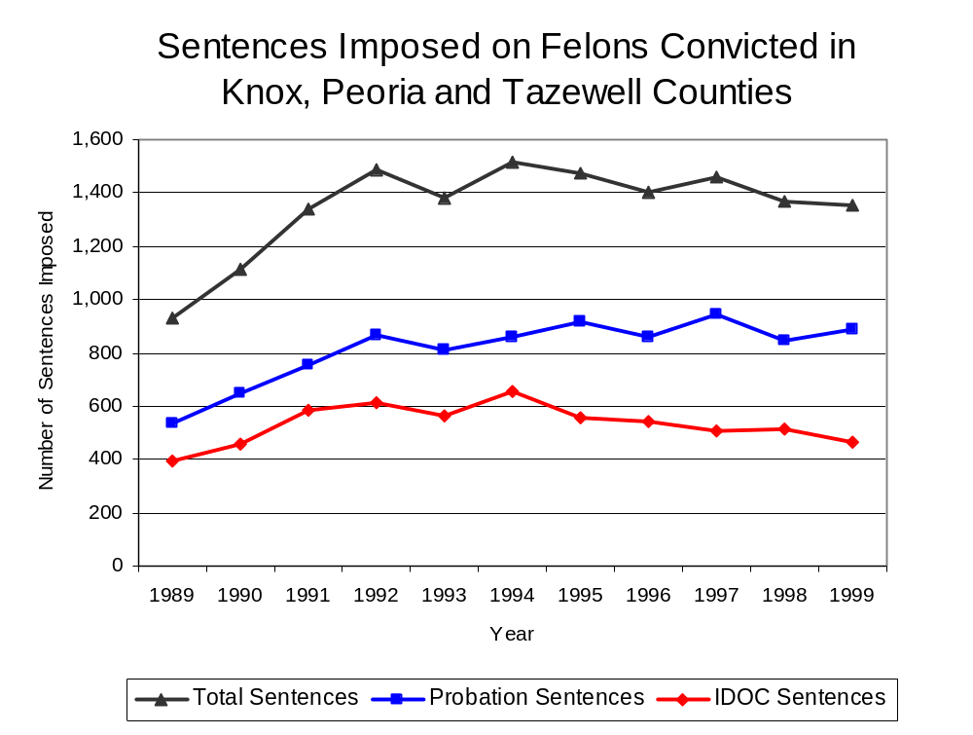
Between 1989 and 1999, the number of offenders convicted of a felony and sentenced in the three-county region covered by Multi-County MEG increased 45 percent, from 932 to 1355. Although the number of convicted felons sentenced to the Illinois Department of Corrections (IDOC) increased between 1989 and 1999, from 395 to 432, the proportion of felons sentenced to IDOC decreased during the same period, from 42 percent to 34 percent of total felony sentences. In 1999, 888 probation sentences were imposed on convicted felons, 66 percent more than in 1989 (Figure 19). As a result, the proportion of felons sentenced to probation increased from 58 percent in 1989 to 66 percent in 1999.
Figure 19
Source: Administrative Office of the Illinois Courts

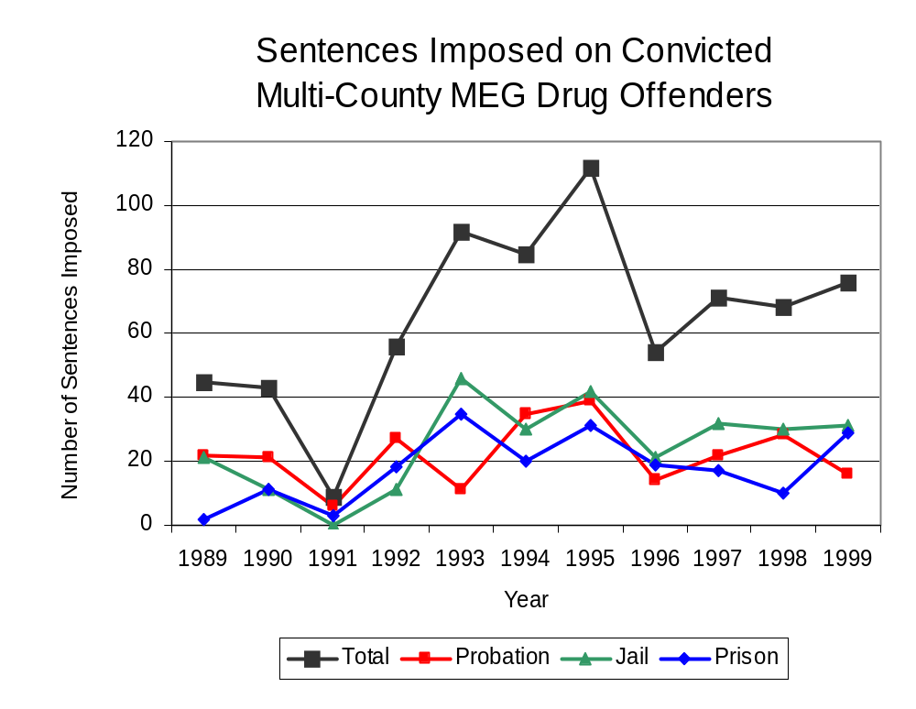
Between 1989 and 1999, the number of Multi-County MEG drug offenders convicted and sentenced increased from 45 to 76. During the period analyzed, the number of convicted Multi-County MEG drug offenders sentenced to jail increased from 43 in 1989 to 47 in 1999 and the number of convicted Multi-County MEG drug offenders sentenced to prison increased from 2 to 29 (Figure 20), while the number sentenced to probation decreased from 22 to 16. In 1999, among those Multi-County MEG drug offenders convicted and sentenced, jail sentences accounted for the largest proportion (41 percent), followed by prison sentences (38 percent) and probation sentences (21 percent).
Figure 20
Source: Multi-County MEG

Between state fiscal years 1989 and 1999, the number of new court commitments to IDOC’s Adult Division for drug offenses from the three-county region covered by Multi-County MEG more than doubled, from 37 to 91. The number of drug offender admissions by Multi-County MEG also increased from 2 to 23 between 1989 and 1999 (Figure 21). Thus, during the period analyzed, prison sentences resulting from Multi-County MEG cases accounted for 20 percent of all drug-law violators sentenced to prison from the region where Multi-County MEG operates.
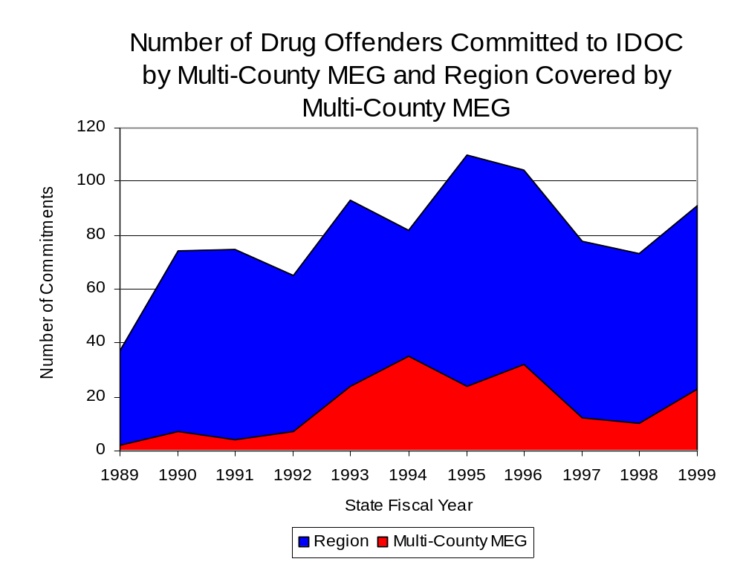
Figure 21
Source: Illinois Department of Corrections and Multi-County MEG

During the period analyzed, drug offenders accounted for an increasing proportion of adults convicted and sentenced to prison from Knox, Peoria and Tazewell counties. In 1989, drug offenses accounted for 12 percent of all commitments to IDOC, compared to 21 percent in 1999 (Figure 22).
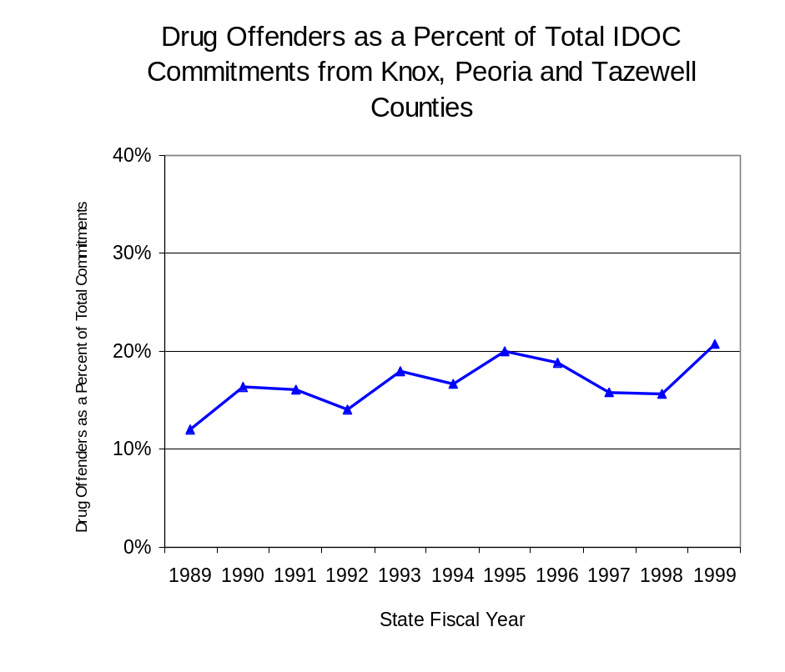
Figure 22
Source: Illinois Department of Corrections

Penalties for drug offenses were also examined between 1993 and 1999. Class 4 felonies accounted for the largest proportion (44 percent) of sentences to IDOC for drug offenses, followed by Class 1 felonies (23 percent), Class 2 felonies (19 percent), while Class 3 and Class X felonies each accounted for 7 percent of the admissions for drug-law violations. Between 1993 and 1999, the number of Class 1 felony sentences increased from 18 to 29, while Class 4 felony sentences increased from 25 to 42 and Class 2 felony sentences increased from 14 to 16. The number of Class X and Class 3 felonies decreased during the period analyzed (Figure 23).

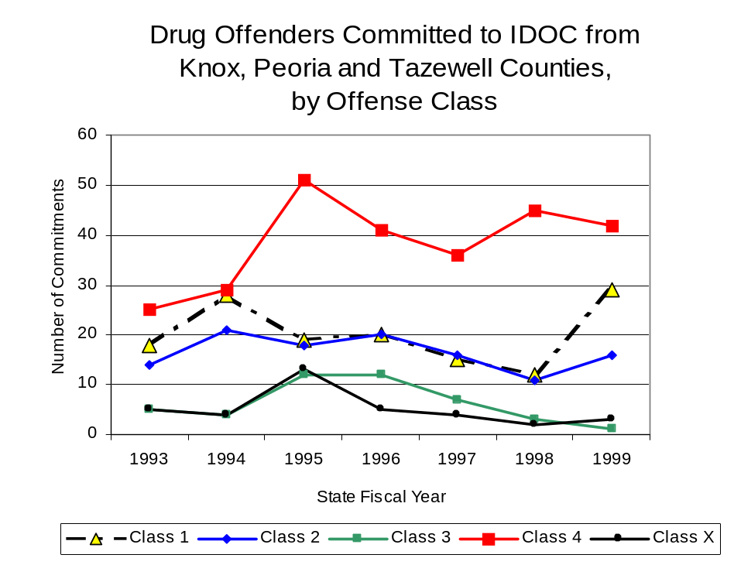
Despite the dramatic increase in Class 4 felony sentences to IDOC between 1993 and 1999, the mean sentence length for Class 4 felonies decreased slightly, from 2.8 years to 2.5 years. However, the mean sentence length for Class 3 felonies increased from 2.7 to 4.5 years. Conversely, the mean sentence length for Class 1, Class 2 and Class X felonies decreased. Class 1 felonies decreased from 6.2 years to 5.1 years, Class 2 felonies decreased from 4.1 to 3.5 years and Class X felonies decreased from 7.5 to 6.4 years.
Figure 23
Source: Illinois Department of Corrections

VII. Trends in Drug Treatment Admissions in Multi-County MEG
Region by Drug Type

In addition to considering indicators of the extent and nature of drug abuse as reported through the criminal justice system (for example, arrests and prison sentences), there are indicators of substance abuse available from other Illinois social service agencies. Overseeing and supporting treatment for substance users, whether they are referred from the criminal justice system or elsewhere, is the responsibility of the Illinois Department of Human Services’ Office of Alcoholism and Substance Abuse (OASA). It is important to note, however, that while OASA data represent the majority of the overall demand for substance abuse treatment in the state, some private programs provide treatment services to a smaller but significant number of clients who may not be included in the state’s reporting system.

In state fiscal year 1999, OASA reported 3,855 admissions for alcohol or drug abuse treatment from Knox, Peoria and Tazewell counties, 38 percent more than the 2,792 admissions in 1989 (Figure 24). Among the 3,855 admissions to substance abuse treatment in state fiscal year 1999, 52 percent (2,012) reported alcohol as their primary substance of abuse, while abuse of illicit substances accounted for 46 percent, and 2 percent reported no primary substance of abuse.

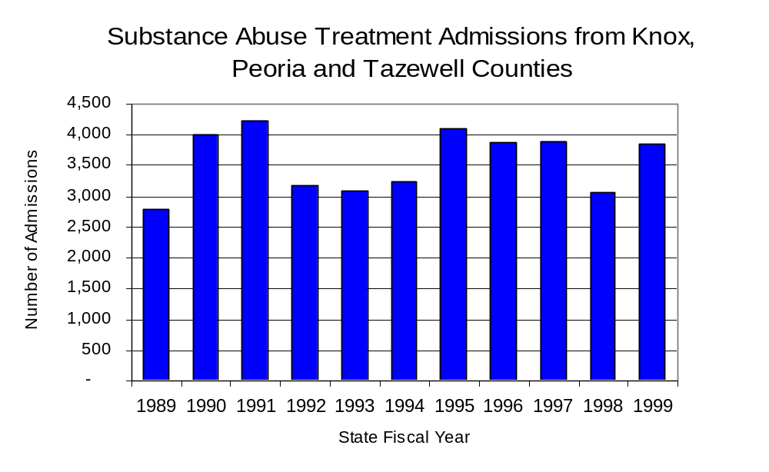
Figure 24
Source: Illinois Department of Human Services’
Office of Alcoholism and Substance Abuse
While drug treatment admissions can be considered a measure of the demand placed on a specific component of the human services system within Illinois, the extent and nature of drug treatment admissions could also be indicative of the substance abuse problem within a particular region. In some respects, the characteristics of those admitted to drug treatment can be considered a profile of the most serious drug abusers in the community, since admission to treatment requires a documented, formal assessment of a drug problem and a level of substance abuse warranting treatment. By comparing the types of drugs of abuse reported by those admitted to substance abuse treatment with the types of drugs involved in law enforcement agency arrests, one can get a sense of the degree to which arrests reflect the drugs which are most problematic within a community.

In the following analyses, the percent of arrests accounted for by drugs classified under Illinois’ Controlled Substances Act (primarily cocaine, heroin, and methamphetamine) versus the Cannabis Control Act (marijuana) across the participating agencies combined, non-participating agencies combined and Multi-County MEG are compared to the proportion of drug treatment admissions accounted for by these groups of substances. From these comparisons, a number of general conclusions can be made. First, the proportion of arrests made by Multi-County MEG accounted for by drugs other than marijuana (Controlled Substances Act offenses) was slightly greater than the proportion of drug treatment admissions from the covered region accounted for by these substances. On the other hand, the majority of arrests by local police departments (including those participating in Multi-County MEG and non-participating agencies) were for cannabis offenses. Thus, while local arrests may reflect the most widely available and used drug in the region, they did not tend to involve the substances considered to be most serious (i.e., felony versus misdemeanor) nor the substances for which individuals were seeking and receiving treatment (Figure 25).

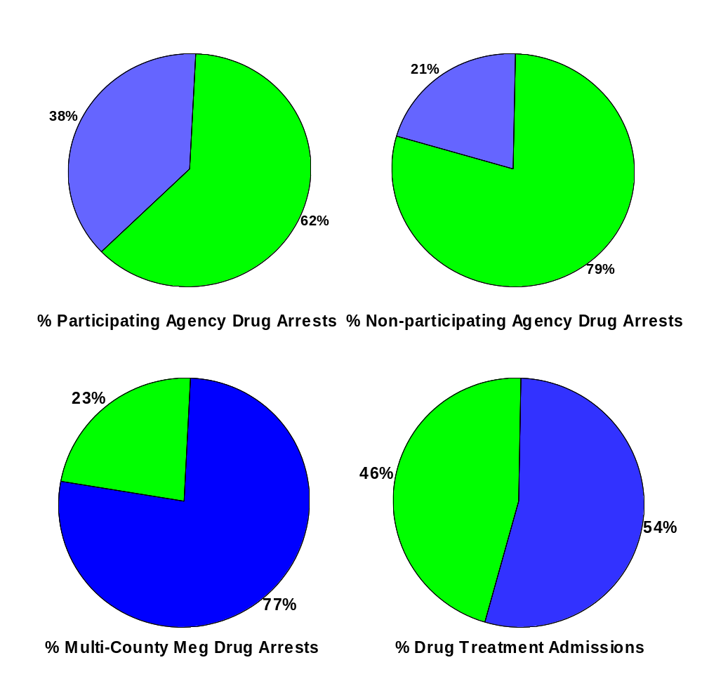
Source: Illinois Department of Human Services’
Office of Alcoholism and Substance Abuse and Multi-County MEG

CannabisControlled Substances
Comparison of Drug Arrests by Multi-County MEG and Participating and Non-participating Agencies vs. Drug Abuse Treatment Admissions in Knox, Peoria and Tazewell Counties, 1999
Figure 25

VIII. Trends in Drug Exposed Births

Illinois continues to experience the effects of prenatal substance abuse. In Illinois, if a baby is born and thought to have been exposed to illegal substances or alcohol, either through observation by physicians or toxicology tests, the case is reported to the Illinois Department of Children and Family Services. These cases are then investigated by DCFS to verify the child’s prenatal exposure to either alcohol or illegal substances. Between state fiscal years 1989 and 1999, nearly one-half (50) of Illinois’ 102 counties reported at least one case of a substance-affected infant.

Between state fiscal years 1989 and 1994, the number of drug-exposed infant cases reported in the three-county region covered by Multi-County MEG soared from a period low of 13 in 1989 to a period high of 66 during 1993, before decreasing almost every year since, to 25 in 1999. Between state fiscal years 1989 and 1999, 344 cases, or 89 percent of all cases reported, were verified as involving prenatal drug use by a DCFS investigation. Mirroring the trend of reported cases, verified cases of drug-exposed infants in the Multi-County MEG region also jumped dramatically between 1989 and 1994 from nine to 62 before dropping to 21 cases in 1999 (Figure 26).

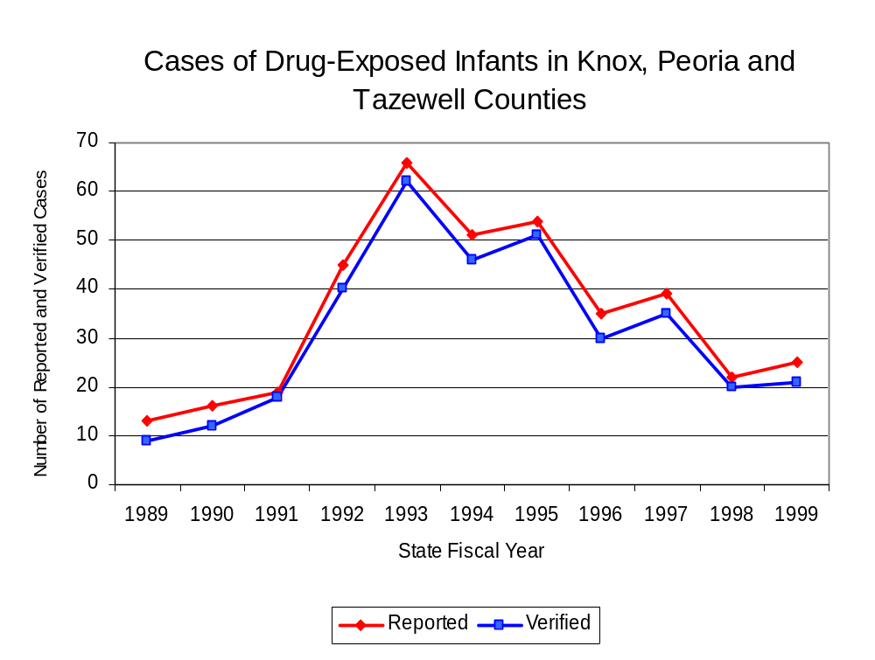
Source: Department of Children and Family Services
Figure 26

IX. Summary of Drug Situation

Although the distribution of illegal drugs is difficult to measure precisely, data obtained from criminal justice sources can be helpful in estimating drug availability. Information from a recent survey of Illinois drug enforcement units, as well as the most up-to-date data available on drug price, are presented as indicators of the drug supply in Illinois.

In 1995, 1996 and 1998, the Authority conducted a survey of each MEG and task force in Illinois to gauge the perceived availability of drugs in the areas they cover. Questions were asked concerning the availability of specific drugs, and results were analyzed by region of the state. MEGs and task forces are classified as being either urban, rural or mixed urban/rural based upon the classification of the county(s) that each unit covers, and, for purposes of this report, are compared to the average of similar units.

According to Multi-County MEG survey responses, cannabis, cocaine and crack continued to be the most visible drugs on the street and were all reported to be “readily available” across all regions analyzed. While perceived availability of most drugs remained relatively unchanged in the three-county region covered by Multi-County MEG, the perceived availability of LSD has decreased slightly since the 1996 survey, while all other drug types increased slightly across Illinois and all MEGs and task forces in mixed urban/rural regions similar to Multi-County MEG. Methamphetamine was reported as moderately available across Illinois but available to a somewhat lesser degree in the region covered by Multi-County MEG and by all MEGs and task forces in mixed urban/rural regions. On the other hand, heroin appears to be more readily available in the three-county region covered by Multi-County MEG than across the state and all other MEGs and task forces in mixed urban/rural regions (Figure 27).
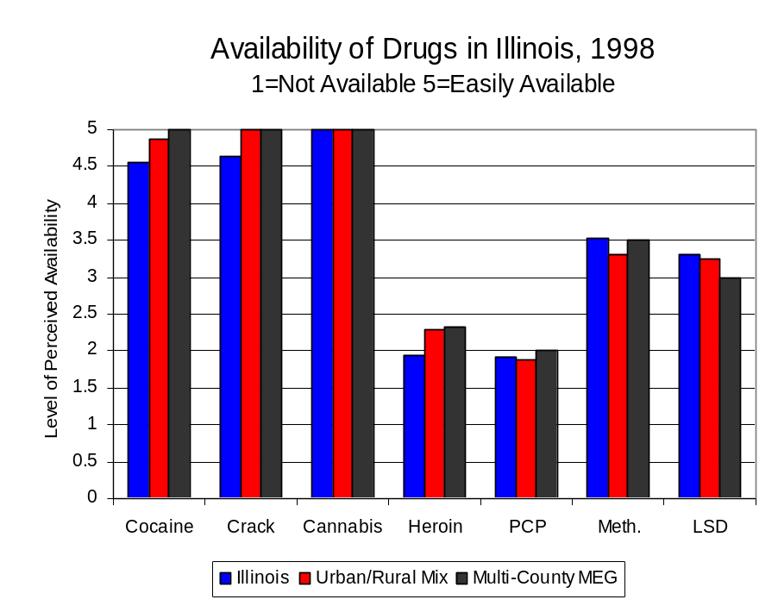
Figure 27
Source: Authority Survey of Illinois MEGs and task forces
Another market indicator that can be used to assess availability is drug price. Lower prices tend to suggest a sufficient supply to meet demand, while increasing prices indicate decreased availability.

Based on a statewide survey of MEG and task force units, the average price of cocaine, crack and methamphetamine appear to be relatively stable across all regions surveyed in 1998, while prices for PCP and heroin appear to vary somewhat across Illinois. The average price of cannabis, cocaine and heroin in the region covered by Multi-County MEG stayed the same between 1996 and 1998, while it increased in the other mixed urban/rural regions. The 1998 average price of cocaine reported by Multi-County MEG was $100 per gram, compared to $98 per gram across Illinois and $103 per gram reported by all MEGs and task forces in other mixed urban/rural regions (Figure 28). On the other hand, the average price of heroin in the region covered by Multi-County MEG was reported as $100 per gram, lower than the price of $165 per gram across Illinois and the price of $214 per gram reported by all other MEGs and task forces in mixed urban/rural regions. In 1998, the average price of cannabis was reported as approximately $10 per gram in the Multi-County MEG region, $7 per gram in primarily mixed urban/rural regions and $8 per gram across Illinois.

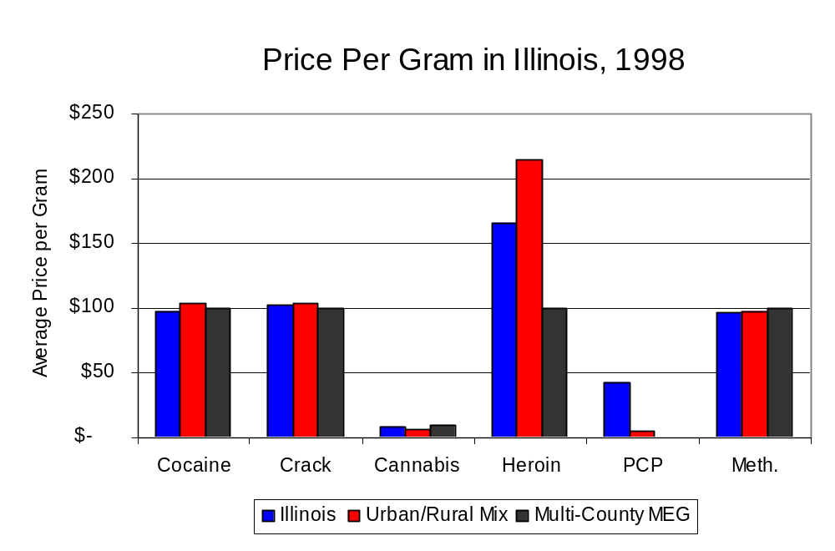
Figure 28
Source: Authority Survey of Illinois MEGs and task forces

X. Appendices
1999 Percent of Illinois'
County-level Population Covered by an Authority-funded Multi-jurisdictional Enforcement Group or Task Force
Map 1
* Shaded counties indicate that at least one law enforcement agency within the county participates in a MEG or task force
Percent of County Population Covered by MEG or Task Force

1999 Illinois
Cannabis
Seizure Rates, by County
Map 2
Cannabis Seizure Rate
(rate per 100,000 population)
1999 Illinois
Cocaine
Seizure Rates, by County
Map 3
Cocaine Seizure Rate
(rate per 100,000 population)
1999 Illinois Methamphetamine
Seizure Rates, by County
Map 4
Methamphetamine Seizure Rate
(rate per 100,000 population)

Bibliography

Administrative Office of the Illinois Courts, Annual Report to the Supreme Court of Illinois.
1989 through 1999 reports, Springfield, Illinois.

Administrative Office of the Illinois Courts’ Probation Division, Statewide Probation Data
Report. 1989 through 1999 reports, Springfield, Illinois.

Illinois Department of Human Services’ Office of Alcoholism and Substance Abuse. Data
provided for state fiscal years 1989 through 1999, Springfield, Illinois.

Illinois Department of Children and Family Services, Child Abuse/Neglect Statistics Report,
1989 through 1999 reports, Springfield, Illinois.

Illinois Department of Corrections. Data provided for fiscal years 1989 through 1999,
Springfield, Illinois.

Illinois State Police, Crime in Illinois. 1993 through 1999 reports, Springfield, Illinois.

Illinois State Police, Drug Statistics Report. Monthly reports, January 1989 through
December 1999, Springfield, Illinois.

Multi-County Metropolitan Enforcement Group. Monthly reports, September January 1989 through December 1999, Peoria, Illinois.

U.S. Bureau of the Census.


George H. Ryan, Governor
Peter B. Bensinger, Chairman
Candice M. Kane, Executive Director

